9 | Compartment Modelling
The time course of drug concentration determined after its administration can be satisfactorily explained by assuming the body as a single well mixed compartment with first-order disposition processes. In case of other drugs, two or more body compartments may be postulated to describe mathematically the data collected.
ONE-COMPARTMENT OPEN MODEL
(Instantaneous Distribution Model)
The one-compartment open model is the simplest model. Owing to its simplicity, it is based on following assumptions –
- The body is considered as a single, kinetically homogeneous unit that has no barriers to the movement of drug.
- Final distribution equilibrium between the drug in plasma and other body fluids (i.e. mixing) is attained instantaneously and maintained at all times. This model thus applies only to those drugs that distribute rapidly throughout the body.
- Drugs move dynamically, in (absorption) and out (elimination) of this compartment.
- Elimination is a first-order (monoexponential) process with first-order rate constant.
- Rate of input (absorption) > rate of output (elimination).
- The anatomical reference compartment is plasma and concentration of drug in plasma is representative of drug concentration in all body tissues i.e. any change in plasma drug concentration reflects a proportional change in drug concentration throughout the body.
However, the model does not assume that the drug concentration in plasma is equal to that in other body tissues. The term open indicates that the input (availability) and output (elimination) are unidirectional and that the drug can be eliminated from the body. Fig. 9.1 shows such a one-compartment model. One-compartment open model is generally used to describe plasma levels following administration of a single dose of a drug.

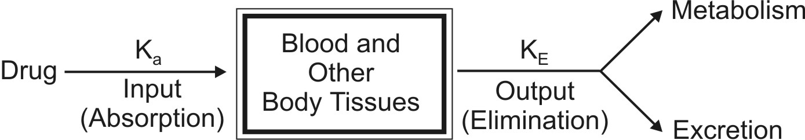
Fig. 9.1 Representation of one-compartment open model showing input and output processes.
Depending upon the rate of input, several one-compartment open models can be defined:
- One-compartment open model, i.v. bolus administration.
- One-compartment open model, continuous i.v. infusion.
- One-compartment open model, e.v. administration, zero-order absorption.
- One-compartment open model, e.v. administration, first-order absorption.
One-Compartment Open Model
Intravenous Bolus Administration
When a drug that distributes rapidly in the body is given in the form of a rapid intravenous injection (i.e. i.v. bolus or slug), it takes about one to three minutes for complete circulation and therefore the rate of absorption is neglected in calculations. The model can be depicted as follows:
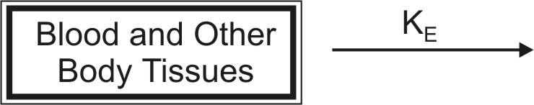
The general expression for rate of drug presentation to the body is:
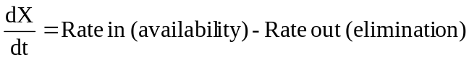 | (9.1)

Since rate in or absorption is absent, the equation becomes:
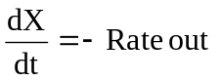 | (9.2)
If the rate out or elimination follows first-order kinetics, then:
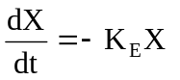 | (9.3)
where, KE = first-order elimination rate constant, and
X = amount of drug in the body at any time t remaining to be eliminated.
Negative sign indicates that the drug is being lost from the body.

Estimation of Pharmacokinetic Parameters
For a drug that follows one-compartment kinetics and administered as rapid i.v. injection, the decline in plasma drug concentration is only due to elimination of drug from the body (and not due to distribution), the phase being called as elimination phase. Elimination phase can be characterized by 3 parameters—
- Elimination rate constant
- Elimination half-life
- Clearance.
Elimination Rate Constant: Integration of equation 9.3 yields:
ln X = ln Xo – KE t | (9.4)
where, Xo = amount of drug at time t = zero i.e. the initial amount of drug injected.
Equation 9.4 can also be written in the exponential form as:
X = Xo e–KEt | (9.5)
The above equation shows that disposition of a drug that follows one-compartment kinetics is monoexponential.
Transforming equation 9.4 into common logarithms (log base 10), we get:
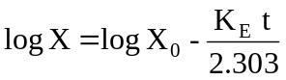 | (9.6)
Since it is difficult to determine directly the amount of drug in the body X, advantage is taken of the fact that a constant relationship exists between drug concentration in plasma C (easily measurable) and X; thus:
X = Vd C | (9.7)
where, Vd = proportionality constant popularly known as the apparent volume of distribution. It is a pharmacokinetic parameter that permits the use of plasma drug concentration in place of amount of drug in the body. The equation 9.6 therefore becomes:
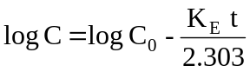 | (9.8)
where, Co = plasma drug concentration immediately after i.v. injection.
Equation 9.8 is that of a straight line and indicates that a semilogarithmic plot of log C versus t will be linear with Y-intercept log Co. The elimination rate constant is directly obtained from the slope of the line (Fig. 9.2b). It has units of min–1. Thus, a linear plot is easier to handle mathematically than a curve which in this case will be obtained from a plot of C versus t on regular (Cartesian) graph paper (Fig. 9.2a).
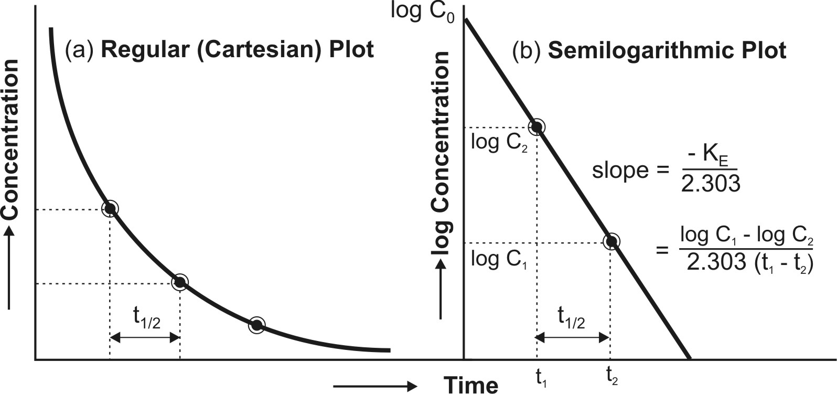
Fig. 9.2 (a) Cartesian plot of a drug that follows one-compartment kinetics and given by rapid i.v. injection, and (b) Semilogarithmic plot for the rate of elimination in a one-compartment model.

Thus, Co, KE (and t½) can be readily obtained from log C versus t graph. The elimination or removal of the drug from the body is the sum of urinary excretion, metabolism, biliary excretion, pulmonary excretion, and other mechanisms involved therein. Thus, KE is an additive property of rate constants for each of these processes and better called as overall elimination rate constant.
KE = Ke + Km + Kb + Kl + ...... | (9.9)
The fraction of drug eliminated by a particular route can be evaluated if the number of rate constants involved and their values are known. For example, if a drug is eliminated by urinary excretion and metabolism only, then, the fraction of drug excreted unchanged in urine Fe and fraction of drug metabolized Fm can be given as:
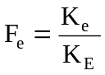 | (9.10a)
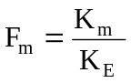 | (9.10b)
Elimination Half-Life: Also called as biological half-life, it is the oldest and the best known of all pharmacokinetic parameters and was once considered as the most important characteristic of a drug. It is defined as the time taken for the amount of drug in the body as well as plasma concentration to decline by one-half or 50% its initial value. It is expressed in hours or minutes. Half-life is related to elimination rate constant by the following equation:
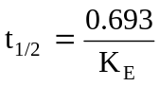 | (9.11)
Elimination half-life can be readily obtained from the graph of log C versus t as shown in Fig 9.2.
Today, increased physiologic understanding of pharmacokinetics shows that half-life is a secondary parameter that depends upon the primary parameters clearance and apparent volume of distribution according to following equation:
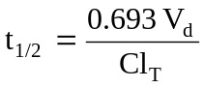 | (9.12)

Apparent Volume of Distribution: The two separate and independent pharmacokinetic characteristics of a drug are –
- Apparent volume of distribution, and
- Clearance.
Since these parameters are closely related with the physiologic mechanisms in the body, they are called as primary parameters.
Modification of equation 9.7 defines apparent volume of distribution:
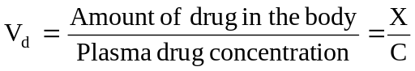 | (9.13)
Vd is a measure of the extent of distribution of drug and is expressed in liters. The best and the simplest way of estimating Vd of a drug is administering it by rapid i.v. injection, determining the resulting plasma concentration immediately and using the following equation:
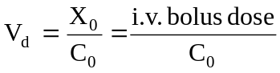 | (9.14)
Equation 9.14 can only be used for drugs that obey one-compartment kinetics. This is because the Vd can only be estimated when distribution equilibrium is achieved between drug in plasma and that in tissues and such equilibrium is established instantaneously for a drug that follows one-compartment kinetics. A more general, more useful noncompartmental method that can be applied to many compartment models for estimating the Vd is:
For drugs given as i.v. bolus,
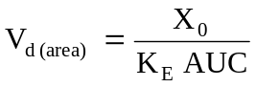 | (9.15a)
For drugs administered extravascularly (e.v.),
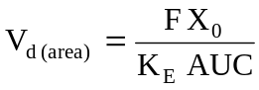 | (9.15b)
where, Xo = dose administered, and F = fraction of drug absorbed into the systemic circulation. F is equal to one i.e. complete availability when the drug is administered intravenously.
Clearance: Difficulties arise when one applies elimination rate constant and half-life as pharmacokinetic parameters in an anatomical/physiological context and as a measure of drug elimination mechanisms. A much more valuable alternative approach for such applications is use of clearance parameters to characterize drug disposition. Clearance is the most important parameter in clinical drug applications and is useful in evaluating the mechanism by which a drug is eliminated by the whole organism or by a particular organ.
Just as Vd is needed to relate plasma drug concentration with amount of drug in the body, clearance is a parameter to relate plasma drug concentration with the rate of drug elimination according to following equation:
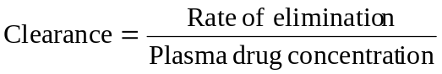 | (9.16)
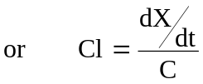 | (9.17)
Clearance is defined as the theoretical volume of body fluid containing drug (i.e. that fraction of apparent volume of distribution) from which the drug is completely removed in a given period of time. It is expressed in ml/min or liters/hour. Clearance is usually further defined as blood clearance (Clb), plasma clearance (Clp) or clearance based on unbound or free drug concentration (Clu) depending upon the concentration C measured for the right side of the equation 9.17.
Total Body Clearance: Elimination of a drug from the body involves processes occurring in kidney, liver, lungs and other eliminating organs. Clearance at an individual organ level is called as organ clearance. It can be estimated by dividing the rate of elimination by each organ with the concentration of drug presented to it. Thus,
Renal Clearance | 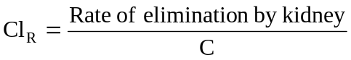 | (9.18a)
Hepatic Clearance | 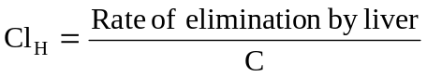 | (9.18b)
Other Organ Clearance | 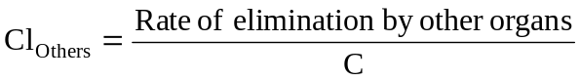 | (9.18c)
The total body clearance, ClT, also called as total systemic clearance, is an additive property of individual organ clearances. Hence,
Total Systemic Clearance | 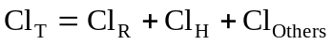 | (9.18d)
Because of the additivity of clearance, the relative contribution by any organ in eliminating a drug can be easily calculated. Clearance by all organs other than kidney is sometimes known as nonrenal clearance ClNR. It is the difference between total clearance and renal clearance.
According to an earlier definition (equation 9.17),
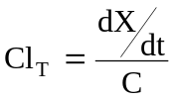 | (9.17)
Substituting dX/dt = KEX from equation 9.3 in above equation, we get:
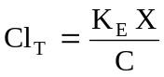 | (9.19)
Since X/C = Vd (from equation 9.13), the equation 9.19 can be written as:
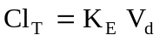 | (9.20a)
Parallel equations can be written for renal and hepatic clearances as:
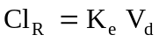 | (9.20b)
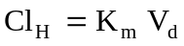 | (9.20c)
Since KE = 0.693/t½ (from equation 9.11), clearance can be related to half-life by the following equation:
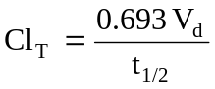 | (9.21)
Identical equations can be written for ClR and ClH in which cases the t½ will be urinary excretion half-life for unchanged drug and metabolism half-life respectively. Equation 9.21. shows that as ClT decreases, as in renal insufficiency, t½ of the drug increases. As the ClT takes into account Vd, changes in Vd as in obesity or oedematous condition will reflect changes in ClT.
The noncompartmental method of computing total clearance for a drug that follows one-compartment kinetics is:
For drugs given as i.v. bolus | 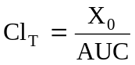 | (9.22a)
For drugs given e.v. | 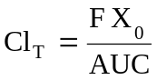 | (9.22b)
For a drug given by i.v. bolus, the renal clearance ClR may be estimated by determining the total amount of unchanged drug excreted in urine, Xu∞ and AUC.
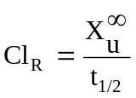 | (9.23)
Organ Clearance: The best way of understanding clearance is at individual organ level. Such a physiologic approach is advantageous in predicting and evaluating the influence of pathology, blood flow, P-D binding, enzyme activity, etc. on drug elimination. At an organ level, the rate of elimination can be written as:
Rate of elimination  by an organ | = | Rate of presentation  to the organ | - | Rate of exit  from the organ | (9.24)

Rate of presentation (input) | = | Organ blood flow | X | Entering concentration | (9.25)
 | = | 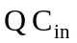 |  |  | (9.25)
Rate of exit (output) | = | Organ blood flow | X | Exiting concentration | (9.26)
 | = | 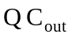 |  |  | (9.26)
Substitution of equations 9.25 and 9.26 in equation 9.24 yields:
Rate of elimination | = | 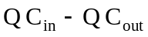 | (9.27)
(also called as Rate of extraction) | = | 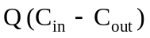 | (9.27)
Division of above equation by concentration of drug that enters the organ of elimination Cin yields an expression for clearance of drug by the organ under consideration. Thus:
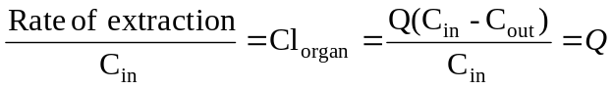 | (9.28)
where, ER = (Cin – Cout)/Cin is called as extraction ratio. It has no units and its value ranges from zero (no elimination) to one (complete elimination). Based on ER values, drugs can be classified into 3 groups:
- Drugs with high ER (above 0.7),
- Drugs with intermediate ER (between 0.7 to 0.3), and
- Drugs with low ER (below 0.3).
ER is an index of how efficiently the eliminating organ clears the blood flowing through it of drug. For example, an ER of 0.6 tells that 60% of the blood flowing through the organ will be completely cleared of drug. The fraction of drug that escapes removal by the organ is expressed as:
F = 1 - ER | (9.29)
where, F = systemic availability when the eliminating organ is liver.
Hepatic Clearance: For certain drugs, the nonrenal clearance can be assumed as equal to hepatic clearance ClH. It is given as:
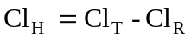 | (9.30)
An equation parallel to equation 9.28 can also be written for hepatic clearance:
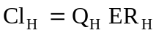 | (9.31)
where, QH = hepatic blood flow (about 1.5 liters/min), and
ERH = hepatic extraction ratio.
The hepatic clearance of drugs can be divided into two groups:
- Drugs with hepatic blood flow rate-limited clearance, and
- Drugs with intrinsic capacity-limited clearance.
1. Hepatic Blood Flow: When ERH is one, ClH approaches its maximum value i.e. hepatic blood flow. In such a situation, hepatic clearance is said to be perfusion rate-limited or flow-dependent. Alteration in hepatic blood flow significantly affects the elimination of drugs with high ERH e.g. propranolol, lidocaine, etc. Such drugs are removed from the blood as rapidly as they are presented to the liver (high first-pass hepatic metabolism). Indocyanine green is so rapidly eliminated by the human liver that its clearance is often used as an indicator of hepatic blood flow rate. First-pass hepatic extraction is suspected when there is lack of unchanged drug in systemic circulation after oral administration. Maximum oral availability F for such drugs can be computed from equation 9.29. An extension of the same equation is the noncompartmental method of estimating F:
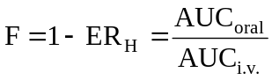 | (9.32)
Table 9.1
Influence of Blood Flow Rate and Protein Binding on Total Clearance of Drugs with High and with Low ER Values
Drugs with | Changes in Total Clearance due to
Drugs with | ↑ Blood Flow | ↓ Blood Flow | ↑ Binding | ↓ Binding
High ER (above 0.7) | ↑ | ↓ | No change | No change
Low ER (below 0.3) | No change | No change | ↓ | ↑
where, ↑ = increase, and ↓ = decrease
On the contrary, hepatic blood flow has very little or no effect on drugs with low ERH e.g. theophylline. For such drugs, whatever concentration of drug present in the blood perfuses liver, is more than what the liver can eliminate (low first-pass hepatic metabolism). Similar discussion can be extended to the influence of blood flow on renal clearance of drugs. This is illustrated in Table 9.1. Hepatic clearance of a drug with high ER is independent of protein binding.
2. Intrinsic Capacity Clearance: Denoted as Clint, it is defined as the inherent ability of an organ to irreversibly remove a drug in the absence of any flow limitation. It depends, in this case, upon the hepatic enzyme activity. Drugs with low ERH and with elimination primarily by metabolism are greatly affected by changes in enzyme activity. Hepatic clearance of such drugs is said to be capacity-limited, e.g. theophylline. The t½ of such drugs show great intersubject variability. Hepatic clearance of drugs with low ER is independent of blood flow rate but sensitive to changes in protein binding.
The hepatic and renal extraction ratios of some drugs and metabolites are given in Table 9.2.
Table 9.2
Hepatic and Renal Extraction Ratio of Some Drugs and Metabolites
 | Extraction Ratio
 | High | Intermediate | Low
Hepatic Extraction | Propranolol  Lidocaine  Nitroglycerine  Morphine  Isoprenaline | Aspirin  Codeine  Nortriptyline  Quinidine | Diazepam  Phenobarbital  Phenytoin  Procainamide  Theophylline
Renal Extraction | Some penicillins  Hippuric acid  Several sulphates  Several glucuronides | Some penicillins  Procainamide  Cimetidine | Digoxin  Furosemide  Atenolol  Tetracycline

One-Compartment Open Model
Intravenous Infusion
Rapid i.v. injection is unsuitable when the drug has potential to precipitate toxicity or when maintenance of a stable concentration or amount of drug in the body is desired. In such a situation, the drug (for example, several antibiotics, theophylline, procainamide, etc.) is administered at a constant rate (zero-order) by i.v. infusion. In contrast to the short duration of infusion of an i.v. bolus (few seconds), the duration of constant rate infusion is usually much longer than the half-life of the drug.
Advantages of zero-order infusion of drugs include—
1. Ease of control of rate of infusion to fit individual patient needs.
2. Prevents fluctuating maxima and minima (peak and valley) plasma level, desired especially when the drug has a narrow therapeutic index.
3. Other drugs, electrolytes and nutrients can be conveniently administered simultaneously by the same infusion line in critically ill patients.
The model can be represented as follows:
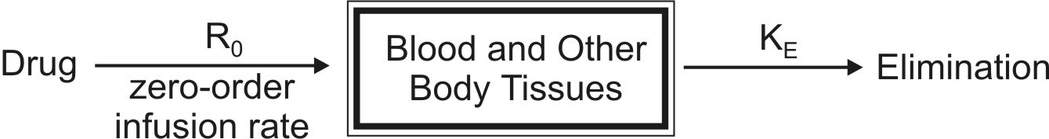
At any time during infusion, the rate of change in the amount of drug in the body, dX/dt is the difference between the zero-order rate of drug infusion Ro and first-order rate of elimination, –KEX:
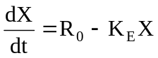 | (9.33)
Integration and rearrangement of above equation yields:
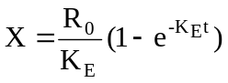 | (9.34)
Since X = Vd C, the equation 9.34 can be transformed into concentration terms as follows:
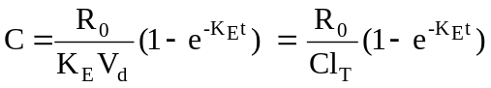 | (9.35)
At the start of constant rate infusion, the amount of drug in the body is zero and hence, there is no elimination. As time passes, the amount of drug in the body rises gradually (elimination rate less than the rate of infusion) until a point after which the rate of elimination equals the rate of infusion i.e. the concentration of drug in plasma approaches a constant value called as steady-state, plateau or infusion equilibrium (Fig. 9.3.).
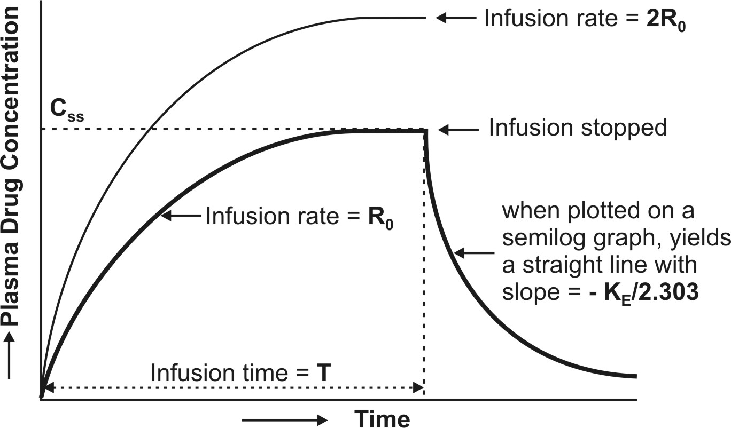
Fig. 9.3. Plasma concentration-time profile for a drug given by constant rate i.v. infusion (the two curves indicate different infusion rates Ro and 2Ro for the same drug)
At steady-state, the rate of change of amount of drug in the body is zero, hence, the equation 9.33 becomes:
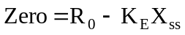
or | 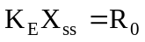 | (9.36)
Transforming to concentration terms and rearranging the equation:
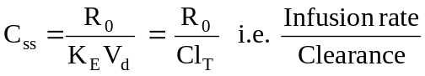 | (9.37)
where, Xss and Css are amount of drug in the body and concentration of drug in plasma at steady-state respectively. The value of KE (and hence t½) can be obtained from the slope of straight line obtained after a semilogarithmic plot (log C versus t) of the plasma concentration-time data gathered from the time when infusion is stopped (Fig. 9.3). Alternatively, KE can be calculated from the data collected during infusion to steady-state as follows:
Substituting Ro/ClT = Css from equation 9.37 in equation 9.35 we get:
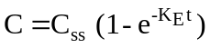 | (9.38)
Rearrangement yields:
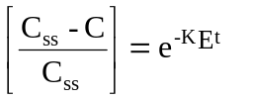 | (9.39)
Transforming into log form, the equation becomes:
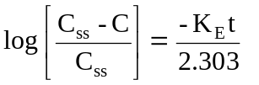 | (9.40)
A semilog plot of (Css – C)/Css versus t results in a straight line with slope –KE/2.303 (Fig. 9.4).
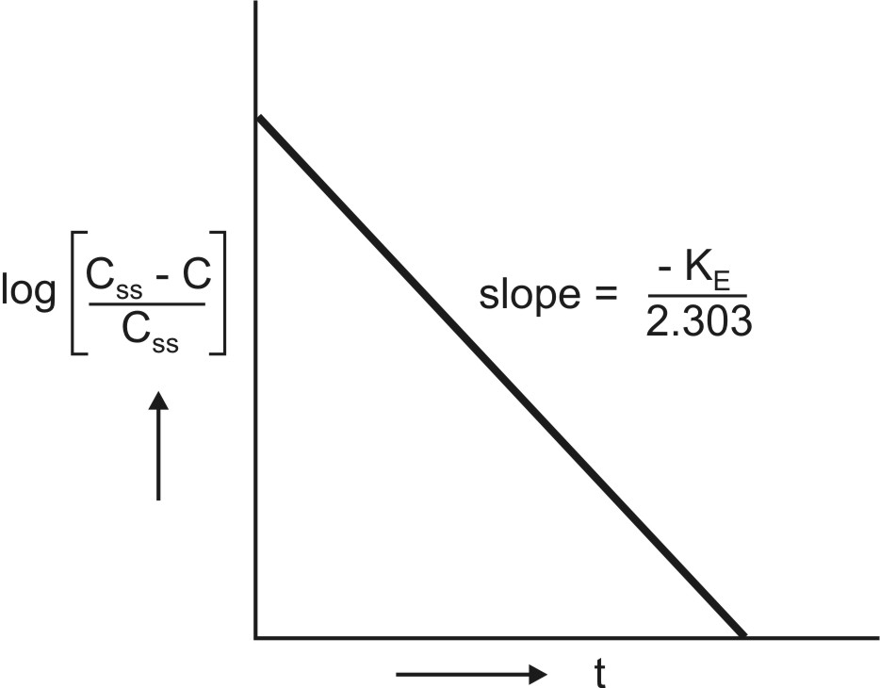
Fig. 9.4 Semilog plot to compute KE from infusion data upto steady-state
The time to reach steady-state concentration is dependent upon the elimination half-life and not infusion rate. An increase in infusion rate will merely increase the plasma concentration attained at steady-state (Fig. 9.3). If n is the number of half-lives passed since the start of infusion (t/t½), equation 9.38 can be written as:
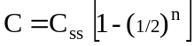 | (9.41)
The percent of Css achieved at the end of each t½ is the sum of Css at previous t½ and the concentration of drug remaining after a given t½ (Table 9.3).
Table 9.3
Percent of Css attained at the end of a given t½
Half-life | % Remaining | % Css Achieved
1 | 50 | 50
2 | 25 | 50 | + | 25 | = | 75
3 | 12.5 | 75 | + | 12.5 | = | 87.5
4 | 6.25 | 87.5 | + | 6.25 | = | 93.75
5 | 3.125 | 93.75 | + | 3.125 | = | 96.875
6 | 1.562 | 96.875 | + | 1.562 | = | 98.437
7 | 0.781 | 98.437 | + | 0.781 | = | 99.218
For therapeutic purpose, more than 90% of the steady-state drug concentration in the blood is desired which is reached in 3.3 half-lives. It takes 6.6 half-lives for the concentration to reach 99% of the steady-state. Thus, the shorter the half-life (e.g. penicillin G, 30 min), sooner is the steady-state reached.
Infusion Plus Loading Dose: It takes a very long time for the drugs having longer half-lives before the plateau concentration is reached (e.g. phenobarbital, 5 days). Thus, initially, such drugs have subtherapeutic concentrations. This can be overcome by administering an i.v. loading dose large enough to yield the desired steady-state immediately upon injection prior to starting the infusion. It should then be followed immediately by i.v. infusion at a rate enough to maintain this concentration (Fig. 9.5).
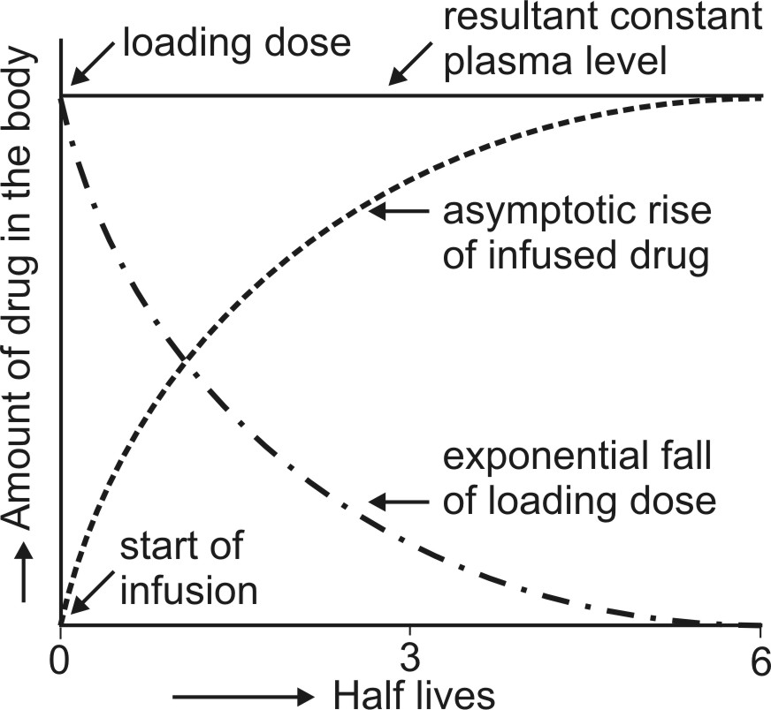
Fig. 9.5 Intravenous infusion with loading dose. As the amount of bolus dose remaining in the body falls, there is a complementary rise resulting from the infusion
Recalling once again the relationship X = VdC, the equation for computing the loading dose Xo,L can be given:
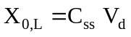 | (9.42)
Substitution of Css = Ro/KEVd from equation 9.37 in above equation yields another expression for loading dose in terms of infusion rate:
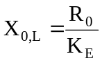 | (9.43)
The equation describing the plasma concentration-time profile following simultaneous i.v. loading dose (i.v. bolus) and constant rate i.v. infusion is the sum of two equations describing each process (i.e. modified equation 9.5 and 9.35):
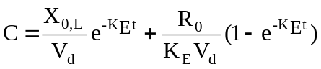 | (9.44)
If we substitute CssVd for Xo,L (from equation 9.42) and CssKEVd for Ro (from equation 9.37) in above equation and simplify it, it reduces to C = Css indicating that the concentration of drug in plasma remains constant (steady) throughout the infusion time.
Assessment of Pharmacokinetic Parameters
The first-order elimination rate constant and elimination half-life can be computed from a semilog plot of post-infusion concentration-time data. Equation 9.40 can also be used for the same purpose. Apparent volume of distribution and total systemic clearance can be estimated from steady-state concentration and infusion rate (equation 9.37). These two parameters can also be computed from the total area under the curve (Fig. 9.3) till the end of infusion:
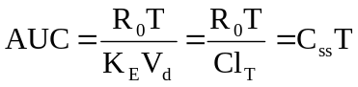 | (9.45)
where, T = infusion time.
The above equation is a general expression which can be applied to several pharmacokinetic models.
One-Compartment Open Model
Extravascular Administration
When a drug is administered by extravascular route (e.g. oral, i.m., rectal, etc.), absorption is a prerequisite for its therapeutic activity. Factors that influence drug absorption have already been discussed in chapter 2. The rate of absorption may be described mathematically as a zero-order or first-order process. A large number of plasma concentration-time profiles can be described by a one-compartment model with first-order absorption and elimination. However, under certain conditions, the absorption of some drugs may be better described by assuming zero-order (constant rate) kinetics. Differences between zero-order and first-order kinetics are illustrated in Fig. 9.6.
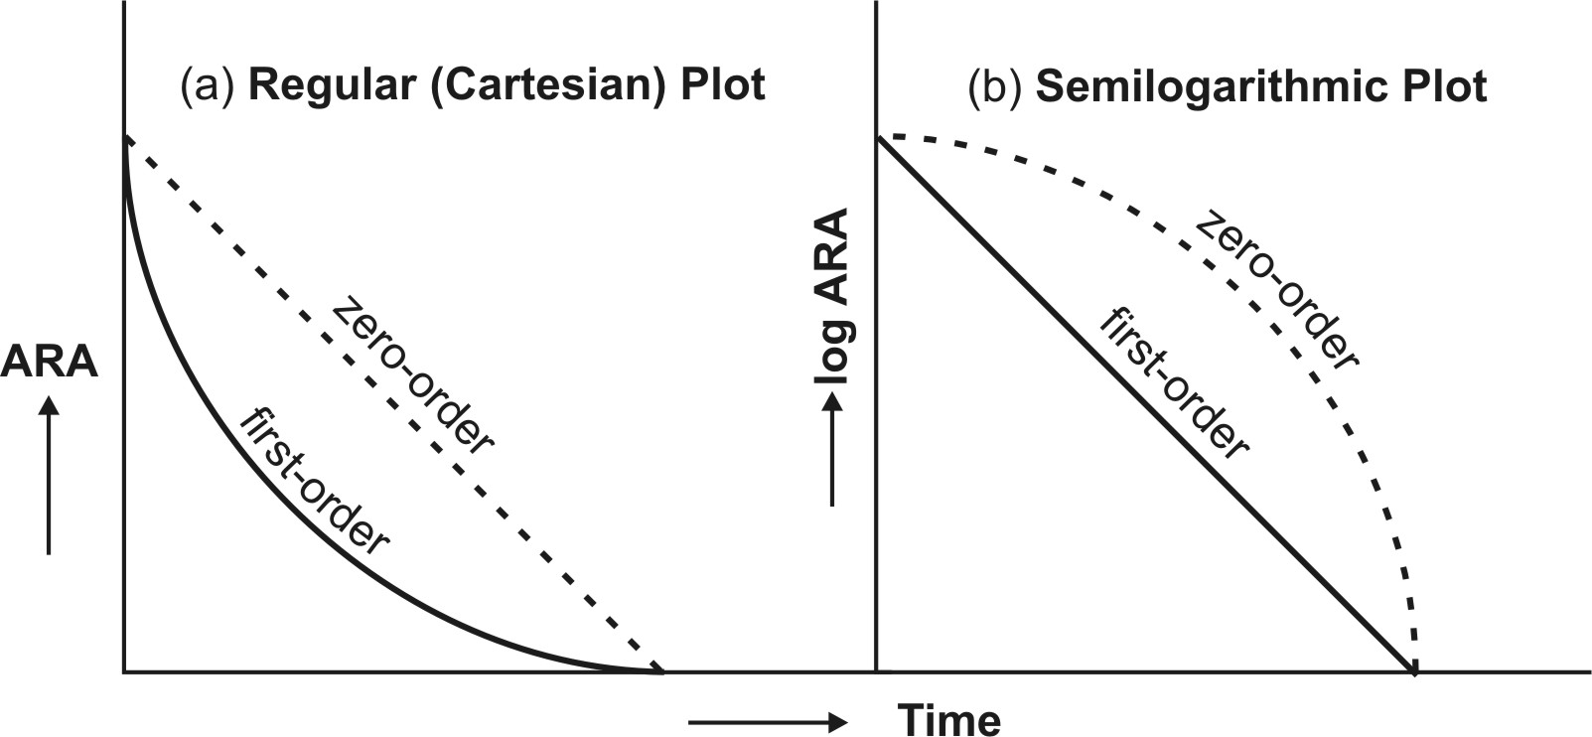
Fig. 9.6 Distinction between zero-order and first-order absorption processes. Figure a is regular plot, and Figure b a semilog plot of amount of drug remaining to be absorbed (ARA) versus time t.
Zero-order absorption is characterized by a constant rate of absorption. It is independent of amount remaining to be absorbed (ARA), and its regular ARA versus t plot is linear with slope equal to rate of absorption while the semilog plot is described by an ever-increasing gradient with time. In contrast, the first-order absorption process is distinguished by a decline in the rate with ARA i.e. absorption rate is dependent upon ARA; its regular plot is curvilinear and semilog plot a straight line with absorption rate constant as its slope.
After e.v. administration, the rate of change in the amount of drug in the body dX/dt is the difference between the rate of input (absorption) dXev/dt and rate of output (elimination) dXE/dt.
dX/dt = Rate of absorption – Rate of elimination
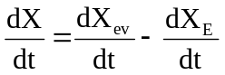 | (9.46a)
For a drug that follows one-compartment kinetics, the plasma concentration-time profile is characterized by absorption phase, post-absorption phase and elimination phase (Fig. 9.7.).
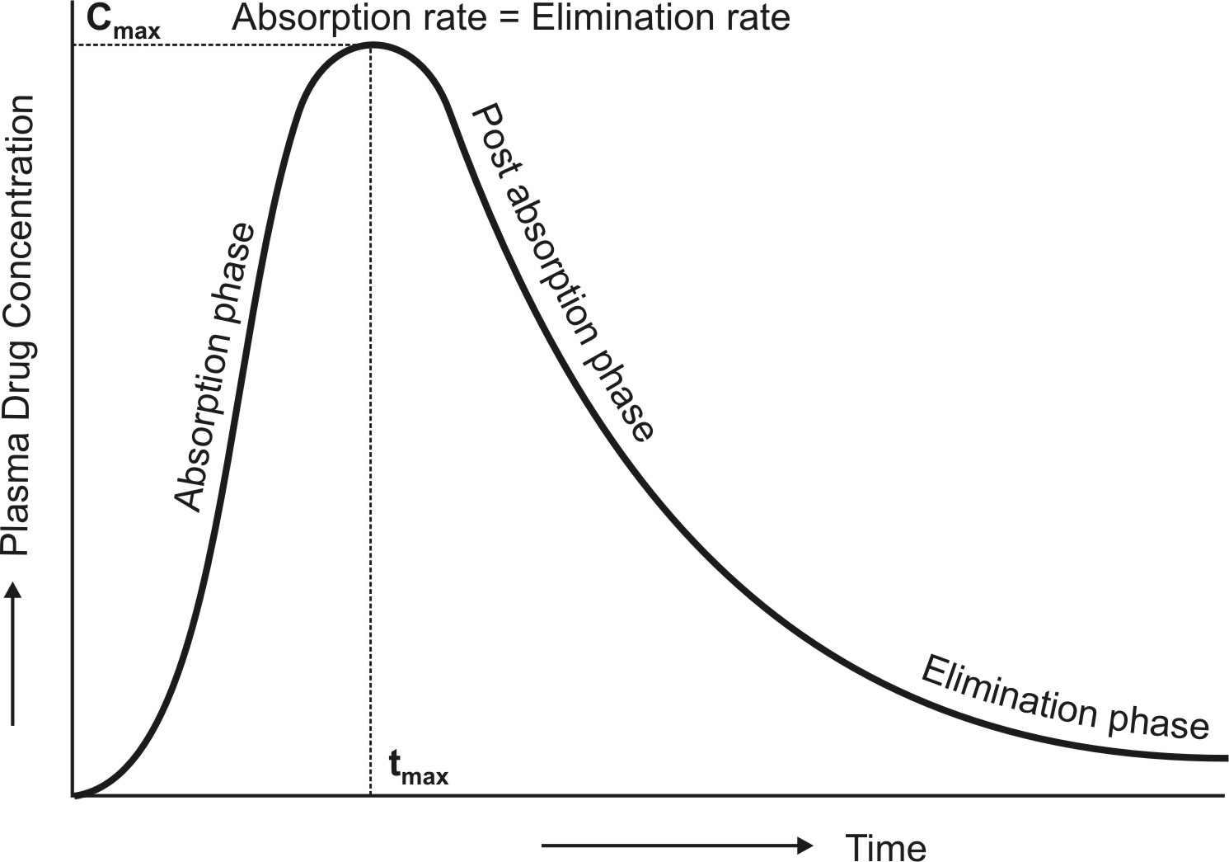
Fig. 9.7 The absorption and elimination phases of the plasma concentration-time profile obtained after extravascular administration of a single dose of a drug.
During the absorption phase, the rate of absorption is greater than the rate of elimination
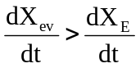 | (9.46b)
At peak plasma concentration, the rate of absorption equals the rate of elimination and the change in amount of drug in the body is zero.
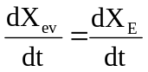 | (9.46c)
During the post-absorption phase, there is some drug at the extravascular site still remaining to be absorbed and the rate of elimination at this stage is greater than the absorption rate.
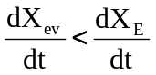 | (9.46d)
After completion of drug absorption, its rate becomes zero and the plasma level time curve is characterized only by the elimination phase.
Zero-Order Absorption Model
This model is similar to that for constant rate infusion.
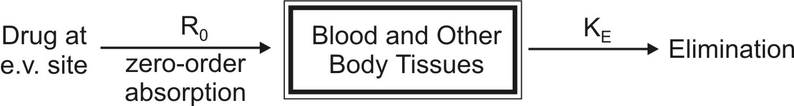
The rate of drug absorption, as in the case of several controlled drug delivery systems, is constant and continues until the amount of drug at the absorption site (e.g. GIT) is depleted. All equations that explain the plasma concentration-time profile for constant rate i.v. infusion are also applicable to this model.
First-Order Absorption Model
For a drug that enters the body by a first-order absorption process, gets distributed in the body according to one-compartment kinetics and is eliminated by a first-order process, the model can be depicted as follows:
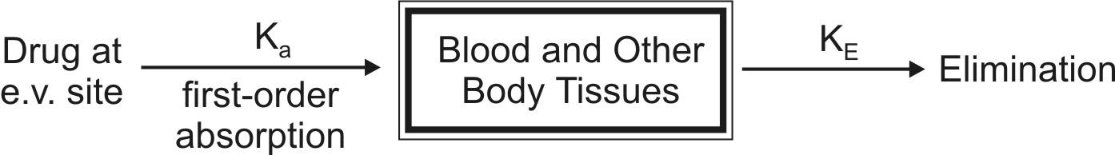
The differential form of the equation 9.46a is:
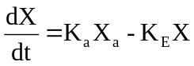 | (9.47)
where, Ka = first-order absorption rate constant, and
Xa = amount of drug at the absorption site remaining to be absorbed i.e. ARA.
Integration of equation 9.47 yields:
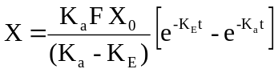 | (9.48)
Transforming into concentration terms, the equation becomes:
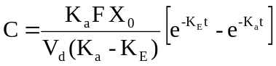 | (9.49)
where F = fraction of drug absorbed systemically after e.v. administration. A typical plasma concentration-time profile of a drug administered e.v. is shown in Fig. 9.7.
Assessment of Pharmacokinetic Parameters
Cmax and tmax: At peak plasma concentration, the rate of absorption equals rate of elimination i.e. KaXa = KEX and the rate of change in plasma drug concentration dC/dt = zero. This rate can be obtained by differentiating equation 9.49.
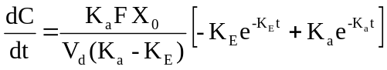 = Zero | (9.50)
On simplifying, the above equation becomes:
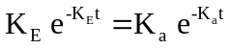 | (9.51)
Converting to logarithmic form,
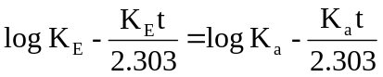 | (9.52)
where t is tmax. Rearrangement of above equation yields:
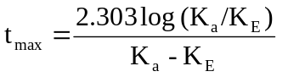 | (9.53)
The above equation shows that as Ka becomes larger than KE, tmax becomes smaller since (Ka – KE) increases much faster than log Ka/KE. Cmax can be obtained by substituting equation 9.53 in equation 9.49. However, a simpler expression for the same is:
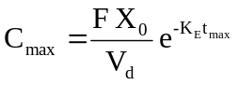 | (9.54)
It has been shown that at Cmax, when Ka = KE, tmax = 1/KE. Hence, the above equation further reduces to:
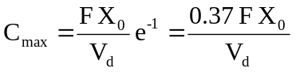 | (9.55)
Since FXo/Vd represents Co following i.v. bolus, the maximum plasma concentration that can be attained after e.v. administration is just 37% of the maximum level attainable with i.v. bolus in the same dose. If bioavailability is less than 100%, still lower concentration will be attained.
Elimination Rate Constant: This parameter can be computed from the elimination phase of the plasma level time profile. For most drugs administered e.v., absorption rate is significantly greater than the elimination rate i.e. Kat >> KEt. Hence, one can say that e–Kat approaches zero much faster than does e–KEt. At such a stage, when absorption is complete, the change in plasma concentration is dependent only on elimination rate and equation 9.49 reduces to:
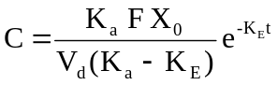 | (9.56)
Transforming into log form, the equation becomes:
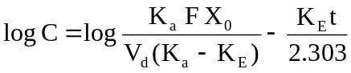 | (9.57)
A plot of log C versus t yields a straight line with slope –KE/2.303 (half-life can then be computed from KE). KE can also be estimated from urinary excretion data (see the section on urinary excretion data).
Absorption Rate Constant: It can be calculated by the method of residuals. The technique is also known as feathering, peeling and stripping. It is commonly used in pharmacokinetics to resolve a multiexponential curve into its individual components. For a drug that follows one-compartment kinetics and administered e.v., the concentration of drug in plasma is expressed by a biexponential equation 9.49.
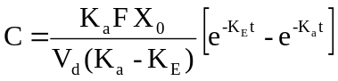 | (9.49)
If KaFXo/Vd(Ka-KE) = A, a hybrid constant, then:
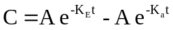 | (9.58)
During the elimination phase, when absorption is almost over, Ka >> KE and the value of second exponential e–Kat approaches zero whereas the first exponential e–KEt retains some finite value. At this time, the equation 9.58 reduces to:
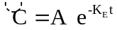 | (9.59)
In log form, the above equation is:
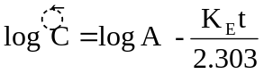 | (9.60)
where 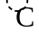 represents the back extrapolated plasma concentration values. A plot of log C versus t yields a biexponential curve with a terminal linear phase having slope –KE/2.303 (Fig. 9.8). Back extrapolation of this straight line to time zero yields y-intercept equal to log A.
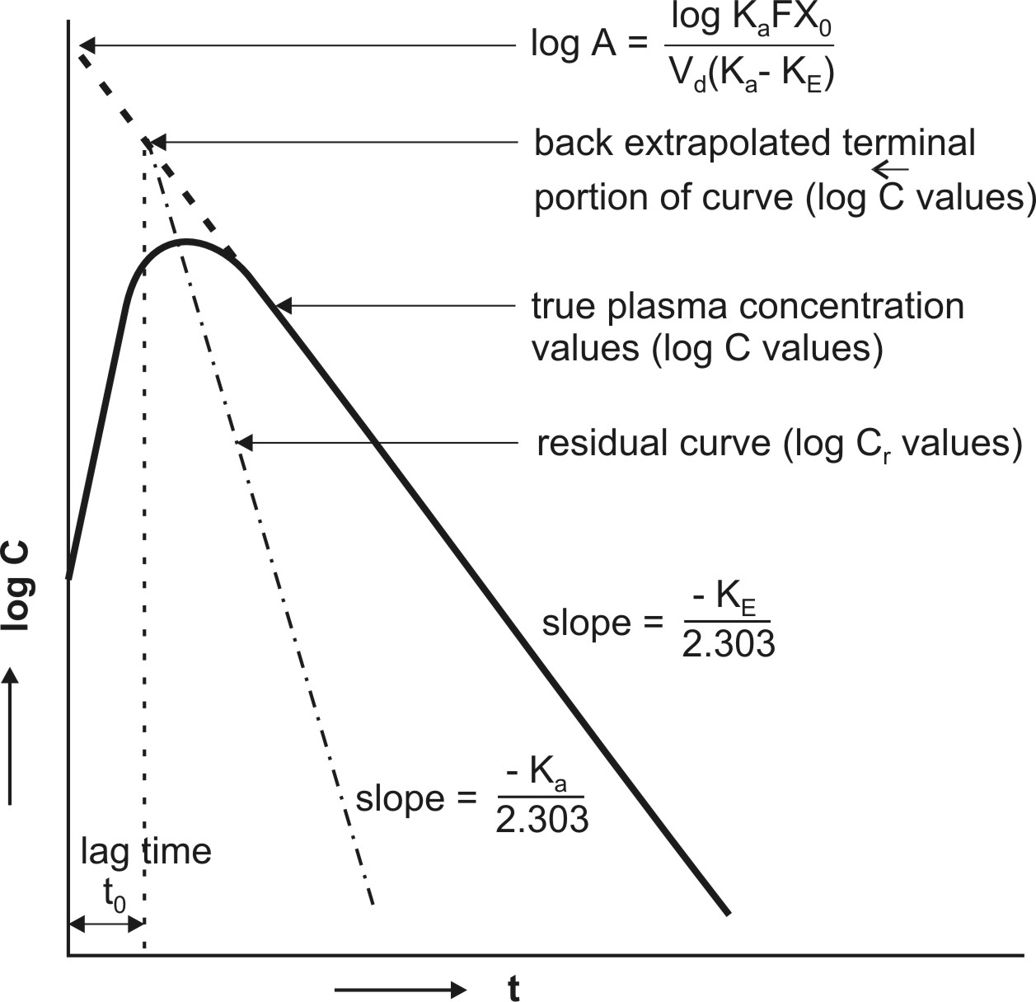
Fig. 9.8 Plasma concentration-time profile after oral administration of a single dose of a drug. The biexponential curve has been resolved into its two components—absorption and elimination.
Subtraction of true plasma concentration values i.e. equation 9.58 from the extrapolated plasma concentration values i.e. equation 9.59 yields a series of residual concentration values Cr :
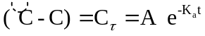 | (9.61)
In log form, the equation is:
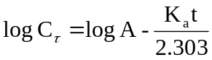 | (9.62)
A plot of log Cr versus t yields a straight line with slope –Ka/2.303 and Y-intercept log A (Fig. 9.8). Absorption half-life can then be computed from Ka using the relation 0.693/Ka. Thus, the method of residuals enables resolution of the biexponential plasma level-time curve into its two exponential components. The technique works best when the difference between Ka and KE is large (Ka/KE ≥ 3). In some instances, the KE obtained after i.v. bolus of the same drug is very large, much larger than the Ka obtained by the method of residuals (e.g. isoprenaline) and if KE/Ka ≥ 3, the terminal slope estimates Ka and not KE whereas the slope of residual line gives KE and not Ka. This is called as flip-flop phenomenon since the slopes of the two lines have exchanged their meanings.
Ideally, the extrapolated and the residual lines intersect each other on y-axis i.e. at time t = zero and there is no lag in absorption. However, if such an intersection occurs at a time greater than zero, it indicates time lag. It is defined as the time difference between drug administration and start of absorption. It is denoted by symbol to and represents the beginning of absorption process. Lag time should not be confused with onset time.
The above method for the estimation of Ka is a curve-fitting method. The method is best suited for drugs which are rapidly and completely absorbed and follow one-compartment kinetics even when given i.v. However, if the absorption of the drug is affected in some way such as GI motility or enzymatic degradation and if the drug shows multicompartment characteristics after i.v. administration (which is true for virtually all drugs), then Ka computed by curve-fitting method is incorrect even if the drug were truly absorbed by first-order kinetics. The Ka so obtained is at best, estimate of first-order disappearance of drug from the GIT rather than of first-order appearance in the systemic circulation.
Wagner-Nelson Method for Estimation of Ka
One of the better alternatives to curve-fitting method in the estimation of Ka is Wagner-Nelson method. The method involves determination of Ka from percent unabsorbed-time plots and does not require the assumption of zero- or first-order absorption.
After oral administration of a single dose of a drug, at any given time, the amount of drug absorbed into the systemic circulation XA, is the sum of amount of drug in the body X and the amount of drug eliminated from the body XE. Thus:
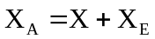 | (9.63)
The amount of drug in the body is X = VdC. The amount of drug eliminated at any time t can be calculated as follows:
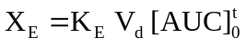 | (9.64)
Substitution of values of X and XE in equation 9.63 yields:
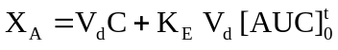 | (9.65)
The total amount of drug absorbed into the systemic circulation from time zero to infinity XA∞ can be given as:
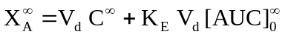 | (9.66)
Since at t = ∞, C∞ = 0, the above equation reduces to:
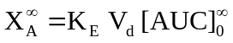 | (9.67)
The fraction of drug absorbed at any time t is given as:
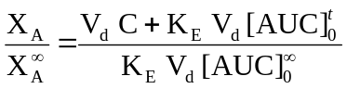
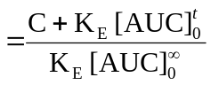 | (9.68)
Percent drug unabsorbed at any time is therefore:
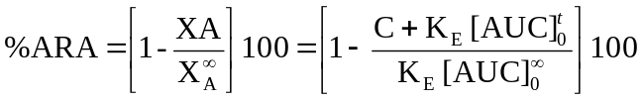 | (9.69)
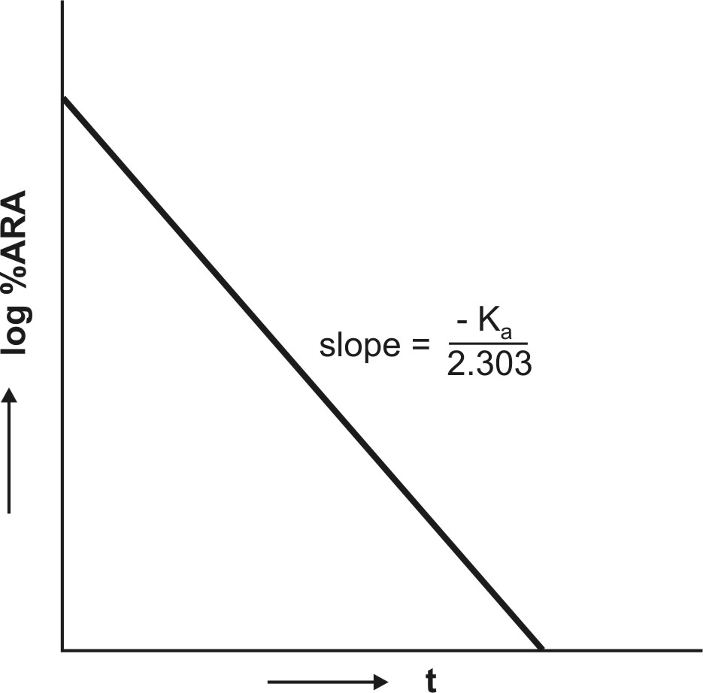
Fig. 9.9 Semilog plot of percent ARA versus t according to Wagner-Nelson method. Similar plot is obtained for Loo-Reigelman method
The method requires collection of blood samples after a single oral dose at regular intervals of time till the entire amount of drug is eliminated from the body. KE is obtained from log C versus t plot and [AUC]ot and [AUC]o∞ are obtained from plots of C versus t. A semilog plot of percent unabsorbed (i.e. percent ARA) versus t yields a straight line whose slope is –Ka/2.303 (Fig.9.9). If a regular plot of the same is a straight line, then absorption is zero-order.
Ka can similarly be estimated from urinary excretion data (see the relevant section). The biggest disadvantage of Wagner-Nelson method is that it applies only to drugs with one-compartment characteristics. Problem arises when a drug that obeys one-compartment model after e.v. administration shows multicompartment characteristics on i.v. injection.
Effect of Ka and KE on Cmax, tmax and AUC
A summary of the influence of changes in Ka at constant KE and of KE at constant Ka on Cmax, tmax and AUC of a drug administered e.v. is shown in Table 9.4.
Table 9.4
Influence of Ka and KE on Cmax, tmax and AUC
Parameters affected | Influence when K_{E} is constant |  | Influence when K_{a} is constant
Parameters affected | Smaller Ka | Larger Ka | Smaller KE | Larger KE
Cmax | ↓ | ↑ | ↑ | ↓
tmax | Long | Short | Long | Short
AUC | No Change | No Change | ↑ | ↓
where, ↑ = increase and ↓ = decrease.
Apparent Volume of Distribution and Clearance: For a drug that follows one-compartment kinetics after e.v. administration, Vd and ClT can be computed from equation 9.15b and 9.22b respectively where F is the fraction absorbed into the systemic circulation.
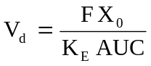 | (9.15b)
 | (9.22b)
URINARY EXCRETION DATA
(Disposition Viewed from Urine only)
In the absence of plasma level-time data, useful information can still be obtained from urine data regarding elimination kinetics of a drug. The method has several advantages in the analysis of a pharmacokinetic system:
1. The method is useful when there is lack of sufficiently sensitive analytical techniques to measure concentration of drugs in plasma with accuracy.
2. The method is non-invasive and therefore better subject compliance is assured.
3. The method is more convenient since it involves collection of urine samples in comparison to drawing of blood periodically.
4. A less sensitive analytical method is required for determining urine drug concentration as compared to plasma concentrations. If urine drug concentrations are low, assaying of larger sample volumes is relatively easy.
5. First-order elimination, excretion and absorption rate constants and fraction excreted unchanged can be computed from such data. First-order metabolism or extra-renal excretion rate constant can also be calculated subsequently from the difference (KE – Ke) = Km.
6. Direct measurement of bioavailability, both absolute and relative, is possible without the necessity of fitting the data to a mathematical model.
7. When coupled with plasma level-time data, it can also be used to estimate renal clearance of unchanged drug according to following equation:
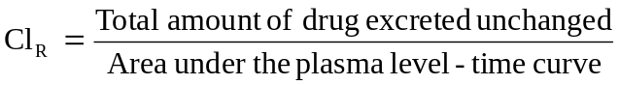 | (9.70)
If Vd is known, total systemic clearance and nonrenal clearance can also be calculated.
One cannot, however, compute Vd and ClT from urine data alone. One must also remember that urinary excretion data is not an accurate substitute for the plasma level data. At best, the data can be employed as a rough estimate of the pharmacokinetic parameters. Moreover, if the drug product provides a very slow drug release or if the drug has a very long biological half-life, the resulting low urinary drug concentration may be too dilute to be assessed with accuracy. In the latter case, i.e. for drugs with long t½, urine may have to be collected for several days to account for total drug excreted.
Criteria for Obtaining Valid Urinary Excretion Data
- A significant amount of drug must be excreted unchanged in the urine (at least 10%).
- The analytical method must be specific for the unchanged drug; metabolites should not interfere.
- Water-loading should be done by taking 400 ml of water after fasting overnight, to promote diuresis and enable collection of sufficient urine samples.
- Before administration of drug, the bladder must be emptied completely after 1 hour from water-loading and the urine sample taken as blank. The drug should then be administered with 200 ml of water and should be followed by 200 ml given at hourly intervals for the next 4 hours.
- Volunteers must be instructed to completely empty their bladder while collecting urine samples.
- Frequent sampling should be done in order to obtain a good curve.
- During sampling, the exact time and volume of urine excreted should be noted.
- An individual collection period should not exceed one biological half-life of the drug and ideally should be considerably less.
- Urine samples must be collected for at least 7 biological half-lives in order to ensure collection of more than 99% of excreted drug.
- Changes in urine pH and urine volume may alter the urinary excretion rate.
Table 9.5
Urinary Excretion Data following i.v. Bolus of 100 mg of a Drug
Observations |  |  |  | Treatment of data
Sample | Time of urine collection  t (hrs) | Volume of urine collected (ml) | Conc. of unchanged drug in urine  (mcg/ml) | Urine collection interval  dt (or Δt) | Midpoint of urine collection  t* | Amount excreted in time interval  dX_{u}/dt  or ΔX_{u} (mg) | Excret. rate (mg/H) | Cumul. amount excreted  X_{u}^{t} (mg) | Amount remaining to be excreted  (X_{u}∞ – X_{u}t)  (mg)
0 | 0 | - | - | - | - | - | - | 0 | 66.7
1 | 0 – 2 | 140 | 250 | 2 | 1 | 35.0 | 17.5 | 35.0 | 31.7
2 | 2 – 4 | 150 | 100 | 2 | 3 | 15.0 | 7.5 | 50.0 | 16.7
3 | 4 – 6 | 90 | 80 | 2 | 5 | 7.2 | 3.6 | 57.2 | 9.5
4 | 6 – 8 | 200 | 20 | 2 | 7 | 4.0 | 2.0 | 61.2 | 5.5
5 | 8 –12 | 310 | 10 | 4 | 10 | 3.1 | 0.8 | 64.3 | 2.4
6 | 12 – 24 | 600 | 04 | 12 | 18 | 2.4 | 0.2 | [66.7] | -
 |  |  |  |  |  |  |  | ↓
 |  |  |  |  |  |  |  | X_{u}∞
The urine data can be set as shown in the Table 9.5. Observations include times of urine collection, volumes collected and concentration of unchanged drug in each sample. These data are treated to derive further information.
Determination of KE from Urinary Excretion Data
The first-order elimination (and excretion) rate constants can be computed from urine data by two methods:
1. Rate of excretion method, and
2. Sigma-minus method.
Rate of Excretion Method: The rate of urinary drug excretion dXu/dt is proportional to the amount of drug in the body X and written as:
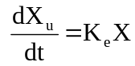 | (9.71)
where Ke = first-order urinary excretion rate constant. According to first-order disposition kinetics, X = Xo e–KEt (equation 9.5). Substituting it in above equation yields:
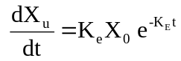 | (9.72)
where Xo = dose administered (i.v. bolus). Transforming to log form the equation becomes:
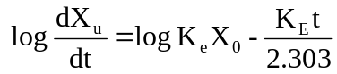 | (9.73)
The above equation states that a semilog plot of rate of excretion versus time yields a straight line with slope –KE/2.303 (Fig. 9.10). It must therefore be remembered that the slope of such an excretion rate versus time plot is related to elimination rate constant KE and not to excretion rate constant Ke. The excretion rate constant can be obtained from the Y-intercept (log Ke Xo). Elimination half-life and nonrenal elimination rate constant can then be computed from KE and Ke.
An advantage of excretion rate method is that for drugs having long half-lives, urine may be collected for only 3 to 4 half-lives. Moreover, there is no need to collect all urine samples since collection of any two consecutive urine samples yield points on the rate plot from which a straight line can be constructed.
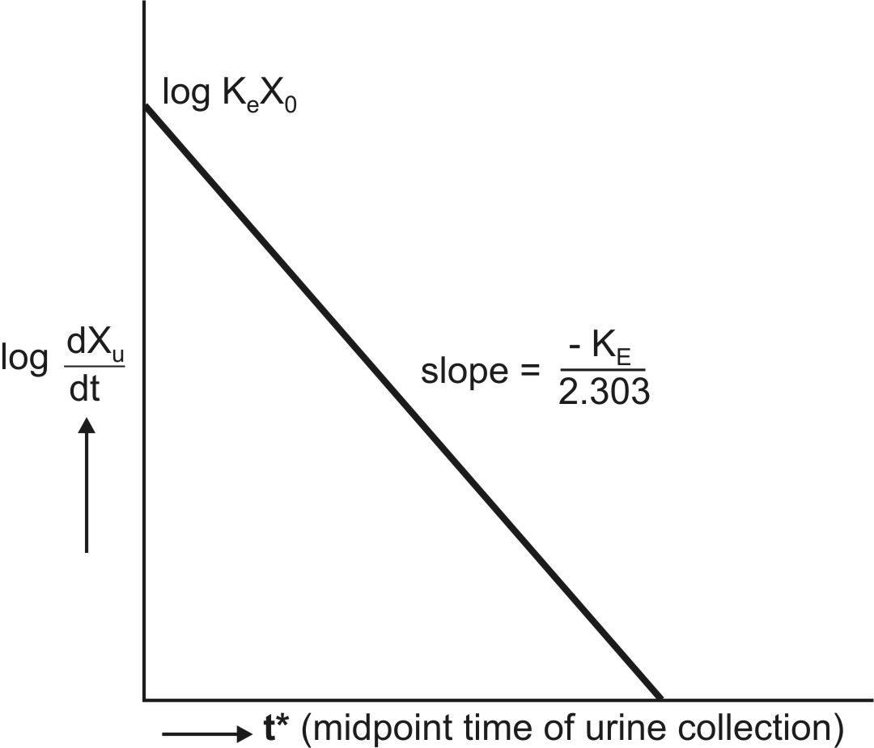
Fig. 9.10 Semilog plot of excretion rate versus mid-point time of urine collection period for computing elimination rate constant after i.v. bolus administration.
Sigma-Minus Method: A disadvantage of rate of excretion method in estimating KE is that fluctuations in the rate of drug elimination are observed to a high degree and in most instances, the data are so scattered that an estimate of half-life is difficult. These problems can be minimized by using the alternative approach called as sigma-minus method.
From an earlier equation:
(9.72)
Integration of equation 9.72 yields:
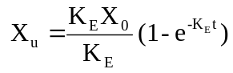 | (9.74)
where Xu = cumulative amount of drug excreted unchanged in urine at any time t. As time approaches infinity i.e. after 6 to 7 half-lives, the value e–KE∞ becomes zero and therefore the cumulative amount excreted at infinite time Xu∞ can be given by equation:
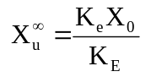 | (9.75)
Substitution of equation 9.75 in equation 9.74 and rearrangement yields:
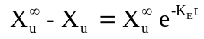 | (9.76)
Converting to logarithms, we get:
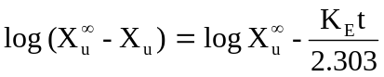 | (9.77)
where (Xu∞ – Xu) = amount remaining to be excreted i.e. ARE at any given time. A semilog plot of ARE versus t yields a straight line with slope -KE/2.303. The method is, therefore, also called as ARE plot method. A disadvantage of this method is that total urine collection has to be carried out until no unchanged drug can be detected in the urine i.e. upto 7 half-lives, which may be tedious for drugs having long t½.
The equations until now for computing KE from the urinary excretion data apply to a drug that fits one-compartment model and given as i.v. bolus. Similarly, data obtained during constant rate i.v. infusion can be used to evaluate the elimination rate constant. The equation that describes the urinary excretion rate of unchanged drug when administered as i.v. bolus also applies when it is administered as i.v. infusion. Thus:
(9.71)
For a drug given as i.v. infusion, the amount of drug in the body X is given by equation (described earlier):
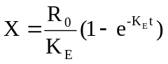 | (9.34)
Substitution of equation 9.34 in equation 9.71 and integration of the same yields:
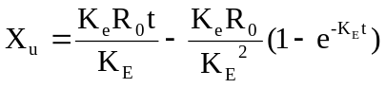 | (9.78)
When the drug has been infused for a period long enough to attain steady-state in the plasma, the term e–KEt approaches zero and the above equation reduces to:
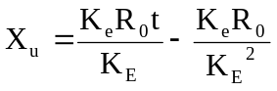 | (9.79)
A regular plot of cumulative amount of drug excreted Xu versus t yields a curvilinear plot the linear portion of which has a slope KeRo/KE. Extrapolation of linear segment to time axis yields x-intercept equal to 1/KE since when Xu = 0, t= 1/KE (Fig. 9.11).
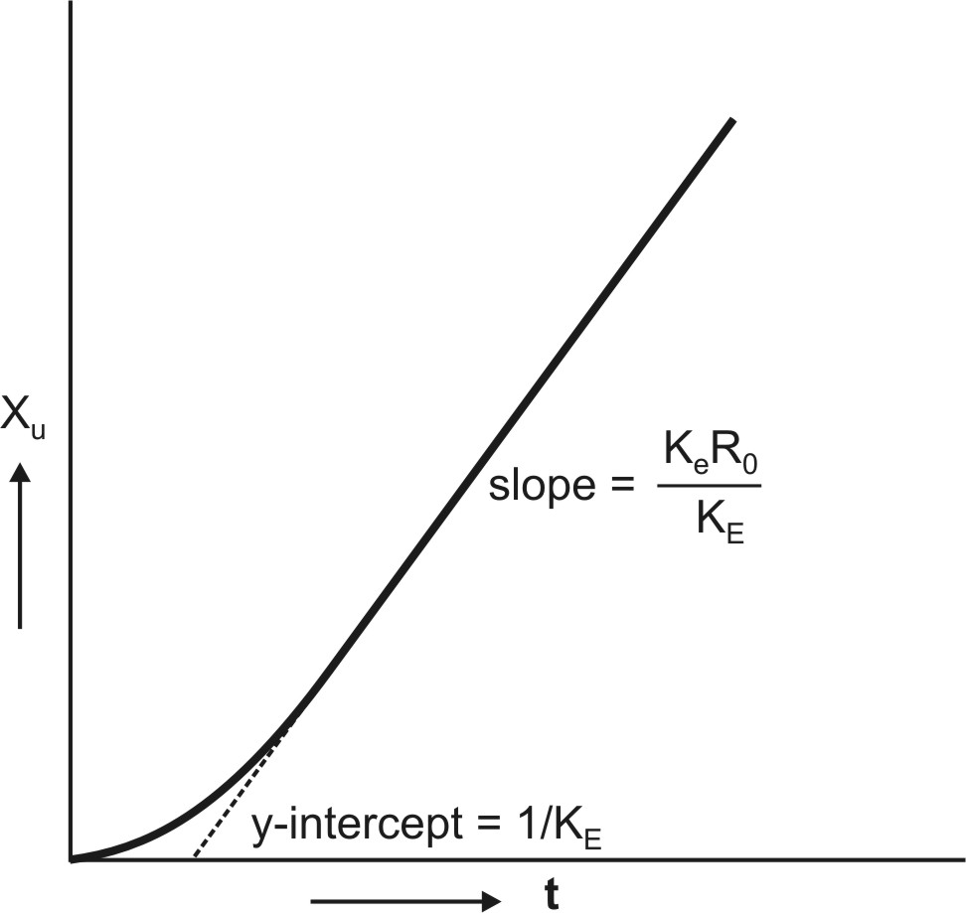
Fig. 9.11. Regular plot of Xu versus t during constant rate i.v. infusion
Relationships for rate of excretion when the drug is administered e.v. can also be given similarly. Thus:
(9.71)
For a drug given e.v. and absorbed by a first-order process, X is given as:
(9.48)
Substitution of equation 9.48 in equation 9.71 and integration of the same yields:
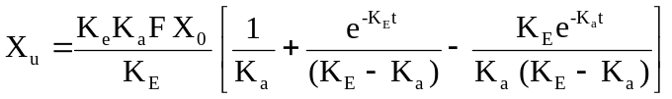 | (9.80)
At time infinity, the equation 9.80 reduces to:
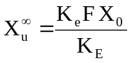 | (9.81)
Substitution of equation 9.81 in equation 9.80 and subsequent rearrangement yields:
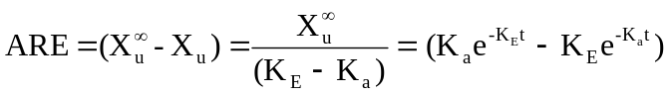 | (9.82)
A semilog plot of (Xu∞ – Xu) versus t results in a biexponential curve and if Ka > KE, the slope of the terminal linear portion of the curve will define KE of the drug. The absorption rate constant Ka can be estimated by the method of residuals using the same data i.e. equation 9.82.
Urinary excretion data after oral administration can also be treated according to Wagner-Nelson method to calculate Ka by construction of % ARA plots. The method requires urine collection for sufficiently long time to ensure accurate estimation of KE but need not be collected to time infinity. The equation derived to relate % ARA with urinary excretion rate is:
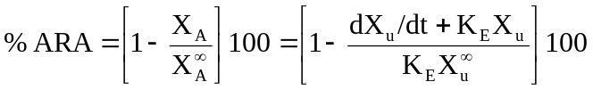 | (9.83)
A semilog plot of % ARA versus t yields a straight line with slope –Ka/2.303.
Accurate determination of Ka from urinary excretion data is possible only for drugs with slow rate of absorption since for drugs with rapid absorption, collection of urine samples at very short intervals of time is difficult.
MULTICOMPARTMENT MODELS
(Delayed Distribution Models)
One-compartment model adequately describes pharmacokinetics of many drugs. Instantaneous distribution equilibrium is assumed in such cases and decline in the amount of drug in the body with time is expressed by an equation with a monoexponential term (i.e. elimination). However, instantaneous distribution is not truly possible for an even larger number of drugs and drug disposition is not monoexponential but bi- or multi-exponential. This is because the body is composed of a heterogeneous group of tissues each with different degree of blood flow and affinity for drug and therefore different rates of equilibration. Ideally, a true pharmacokinetic model should be the one with a rate constant for each tissue undergoing equilibrium, which is difficult mathematically. Multicompartment models are thus based on following assumptions –
- Blood/plasma and the highly perfused tissues such as tissues such as brain, heart, lung, liver and kidneys constitute the central compartment.
- Other tissues with similar distribution characteristics are pooled together to constitute peripheral compartments tissues on the basis of similarity in their distribution characteristics.
- Intravenously administered medications are introduced directly into the central compartment.
- Irreversible drug elimination, either by hepatic biotransformation or renal excretion, takes place only from the central compartment.
- Reversible distribution occurs between central and peripheral compartments, with a finite time required for distribution equilibrium to be attained.
- After drug equilibration between drug and the peripheral compartments, elimination of drug follows first-order kinetics.
- All rate processes involving passage of drug in and out of individual compartment are first-order processes and plasma level-time curve is best described by sum of series of exponential terms each corresponding to first-order rate processes associated with a given compartment.
- The peripheral compartment is usually inaccessible to direct measurement and is not a site of drug elimination or clearance
Multicompartment characteristics of a drug are best understood by giving it as i.v. bolus and observing the manner in which the plasma concentration declines with time. The number of exponentials required to describe such a plasma level-time profile determines the number of kinetically homogeneous compartments into which a drug will distribute.
TWO-COMPARTMENT OPEN MODEL
The commonest of all multicompartment models is a two-compartment model. In such a model, the body tissues are broadly classified into 2 categories –
1. Central Compartment or Compartment 1 comprising of blood and highly perfused tissues like liver, lungs, kidneys, etc. that equilibrate with the drug rapidly. Elimination usually occurs from this compartment.
2. Peripheral or Tissue Compartment or Compartment 2 comprising of poorly perfused and slow equilibrating tissues such as muscles, skin, adipose, etc. and considered as a hybrid of several functional physiologic units.
Classification of a particular tissue, for example brain, into central or peripheral compartment depends upon the physicochemical properties of the drug. A highly lipophilic drug can cross the BBB and brain would then be included in the central compartment. In contrast, a polar drug cannot penetrate the BBB and brain in this case will be a part of peripheral compartment despite the fact that it is a highly perfused organ.
The plasma concentration for a drug that follows a two-compartment model declines biexponentially as the sum of two first-order processes – distribution and elimination.
Depending upon the compartment from which the drug is eliminated, the two-compartment model can be categorized into 3 types:
1. Two-compartment model with elimination from central compartment.
2. Two-compartment model with elimination from peripheral compartment.
3. Two-compartment model with elimination from both the compartments.
In the absence of information, elimination is assumed to occur exclusively from central compartment.
Two-Compartment Open Model
Intravenous Bolus Administration
The model can be depicted as shown below with elimination from the central compartment.
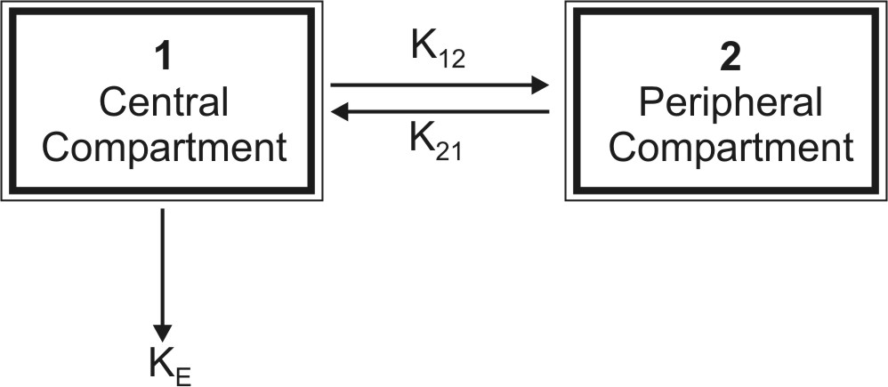
After the i.v. bolus of a drug that follows two-compartment kinetics, the decline in plasma concentration is biexponential indicating the presence of two disposition processes viz. distribution and elimination. These two processes are not evident to the eyes in a regular arithmetic plot but when a semilog plot of C versus t is made, they can be identified (Fig. 9.12). Initially, the concentration of drug in the central compartment declines rapidly; this is due to the distribution of drug from the central compartment to the peripheral compartment. The phase during which this occurs is therefore called as the distributive phase. After sometime, a pseudo-distribution equilibrium is achieved between the two compartments following which the subsequent loss of drug from the central compartment is slow and mainly due to elimination. This second, slower rate process is called as the post-distributive or elimination phase. In contrast to the central compartment, the drug concentration in the peripheral compartment first increases and reaches a maximum. This corresponds with the distribution phase. Following peak, the drug concentration declines which corresponds to the post-distributive phase (Fig.9.12).
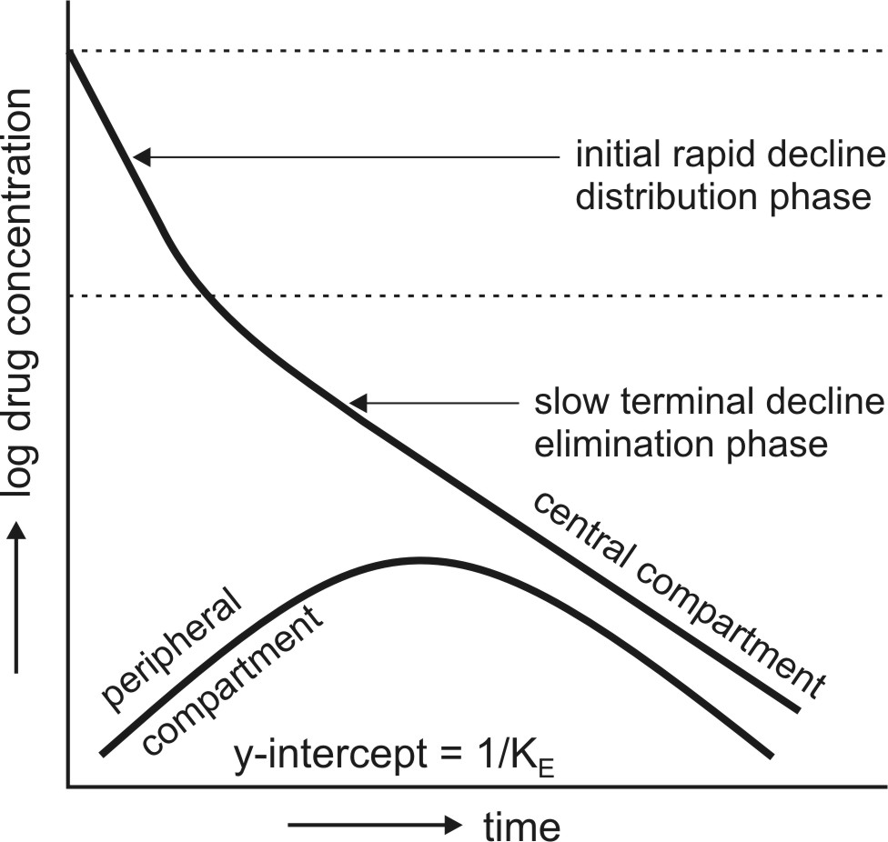
Fig. 9.12. Changes in drug concentration in the central (plasma) and the peripheral compartment after i.v. bolus of a drug that fits two-compartment model.
Let K12 and K21 be the first-order distribution rate constants depicting drug transfer between the central and the peripheral compartments and let subscript c and p define central and peripheral compartment respectively. The rate of change in drug concentration in the central compartment is given by:
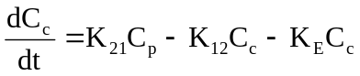 | (9.84)
Extending the relationship X = VdC to the above equation, we have
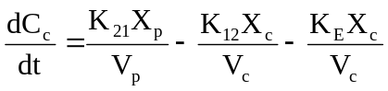 | (9.85)
where Xc and Xp are the amounts of drug in the central and peripheral compartments respectively and Vc and Vp are the apparent volumes of the central and the peripheral compartment respectively. The rate of change in drug concentration in the peripheral compartment is given by:
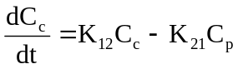
(9.86) | 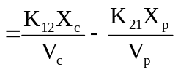
(9.87)Integration of equations 9.85 and 9.87 yields equations that describe the concentration of drug in the central and peripheral compartments at any given time t:
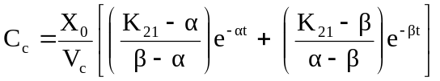 | (9.88)
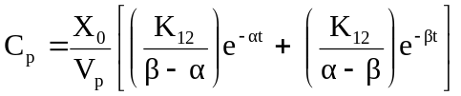 | (9.89)
where Xo = i.v. bolus dose, α and β are hybrid first-order constants for the rapid distribution phase and the slow elimination phase respectively which depend entirely upon the first-order constants K12, K21 and KE.
The constants K12 and K21 that depict reversible transfer of drug between compartments are called as microconstants or transfer constants. The mathematical relationships between hybrid and microconstants are given as:
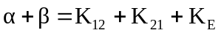 | (9.90)
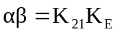 | (9.91)
Equation 9.88 can be written in simplified form as:
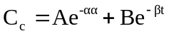 | (9.92)
where A and B are also hybrid constants for the two exponents and can be resolved graphically by the method of residuals.
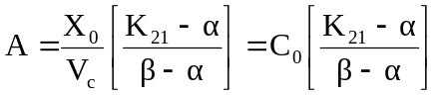 | (9.93)
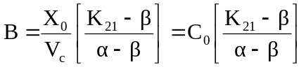 | (9.94)
where Co = plasma drug concentration immediately after i.v. injection.
Method of Residuals: The biexponential disposition curve obtained after i.v. bolus of a drug that fits two compartment model can be resolved into its individual exponents by the method of residuals. Rewriting the equation 9.92:
(9.92)
As apparent from the biexponential curve given in Fig. 9.12., the initial decline due to distribution is more rapid than the terminal decline due to elimination i.e. the rate constant α >> ß and hence the term e–αt approaches zero much faster than does e–βt. Thus, equation 9.92 reduces to:
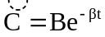 | (9.95)
In log form, the equation becomes:
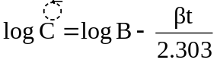 | (9.96)
where C = back extrapolated plasma concentration values. A semilog plot of C versus t yields the terminal linear phase of the curve having slope –β/2.303 and when back extrapolated to time zero, yields y-intercept log B (Fig. 9.13.).The t½ for the elimination phase can be obtained from equation t½ = 0.693/β.
Subtraction of extrapolated plasma concentration values of the elimination phase (equation 9.95) from the corresponding true plasma concentration values (equation 9.92) yields a series of residual concentration values Cr.
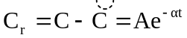 | (9.97)
In log form, the equation becomes:
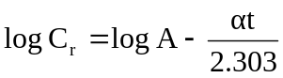 | (9.98)
A semilog plot of Cr versus t yields a straight line with slope –α/2.303 and Y-intercept log A (Fig. 9.13).
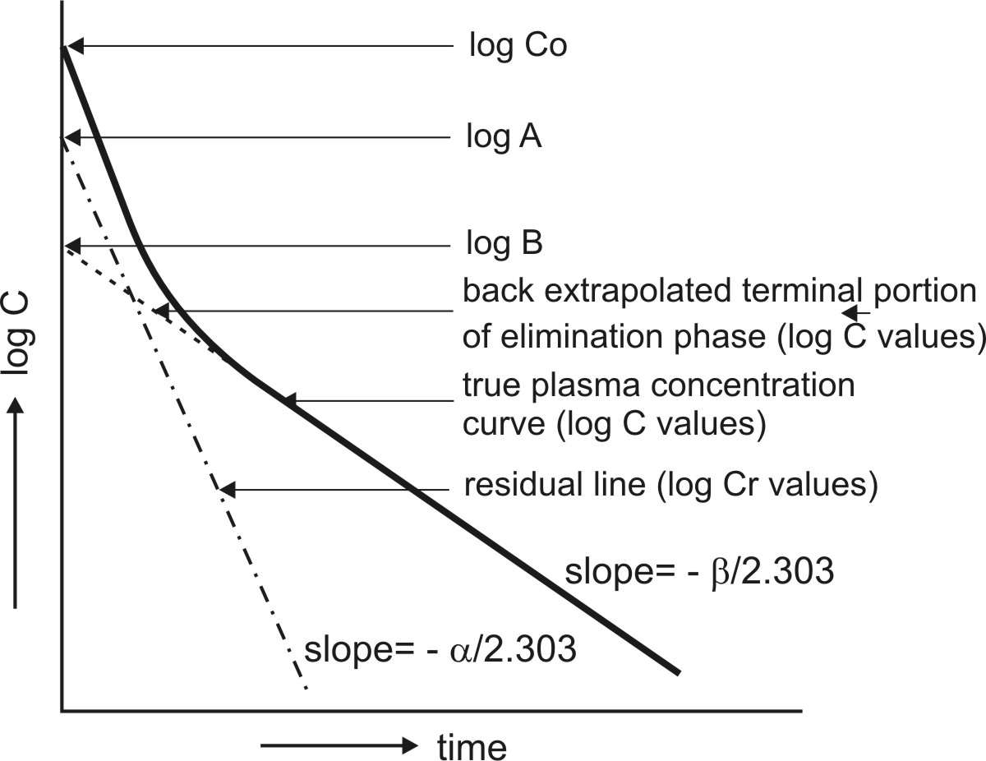
Fig. 9.13. Resolution of biexponential plasma concentration-time curve by the method of residuals for a drug that follows two-compartment kinetics on i.v. bolus administration.
Assessment of Pharmacokinetic Parameters: All the parameters of equation 9.92 can be resolved by the method of residuals as described above. Other parameters of the model viz. K12, K21, KE, etc. can now be derived by proper substitution of these values.
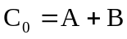 | (9.99)
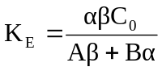 | (9.100)
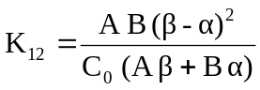 | (9.101)
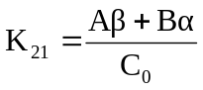 | (9.102)
It must be noted that for two-compartment model, KE is the rate constant for elimination of drug from the central compartment and β is the rate constant for elimination from the entire body. Overall elimination t½ should therefore be calculated from β.
Area under the plasma concentration-time curve can be obtained by the following equation:
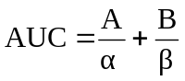 | (9.103)
The apparent volume of central compartment Vc is given as:
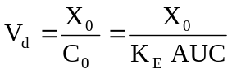 | (9.104)
Apparent volume of peripheral compartment can be obtained from equation:
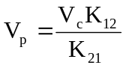 | (9.105)
The apparent volume of distribution at steady-state or equilibrium can now be defined as:
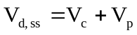 | (9.106)
It is also given as:
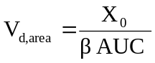 | (9.107)
Total systemic clearance is given as:
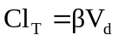 | (9.108)
The pharmacokinetic parameters can also be calculated by using urinary excretion data:
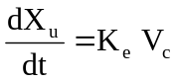 | (9.109)
An equation identical to equation 9.92 can be derived for rate of excretion of unchanged drug in urine:
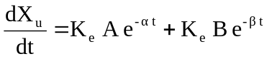 | (9.110)
The above equation can be resolved into individual exponents by the method of residuals as described for plasma concentration-time data.
Renal clearance is given as:
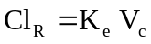 | (9.111)
Two-Compartment Open Model
Intravenous Infusion
The model can be depicted as shown below with elimination from the central compartment.
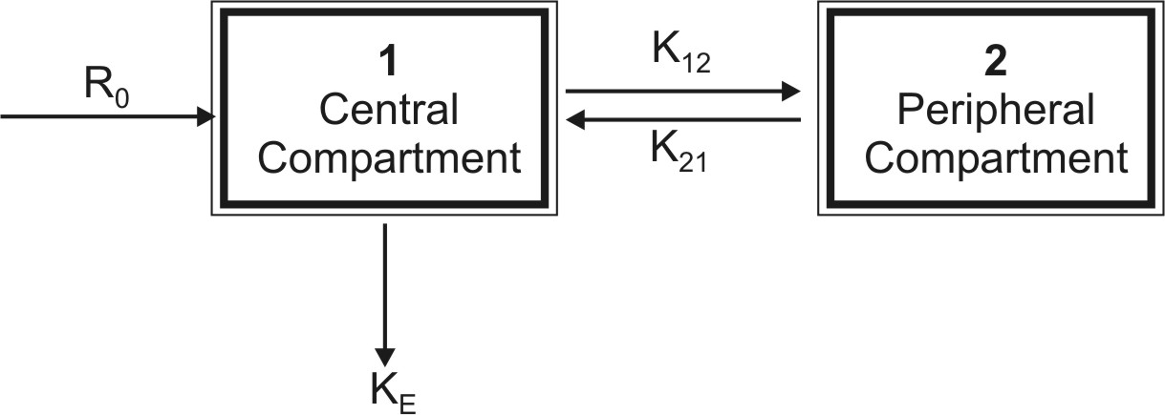
The plasma or central compartment concentration of a drug that fits two-compartment model when administered as constant rate (zero-order) i.v. infusion, is given by equation:
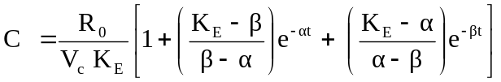 | (9.112)
At steady-state (i.e. at time infinity), the second and the third term in the bracket becomes zero and the equation reduces to:
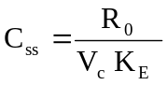 | (9.113)
Now VcKE = Vdß. Substituting this in equation 9.113, we get:
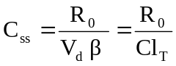 | (9.114)
The loading dose Xo,L to obtain Css immediately at the start of infusion can be calculated from equation:
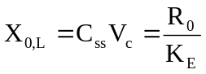 | (9.115)
Two-Compartment Open Model
Extravascular Administration – First-Order Absorption
The model can be depicted as follows:
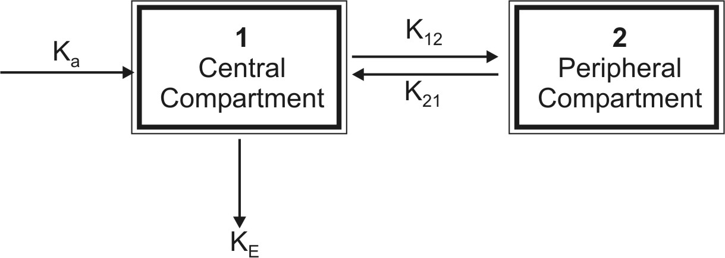
For a drug that enters the body by a first-order absorption process and distributed according to two-compartment model, the rate of change in drug concentration in the central compartment is described by 3 exponents —an absorption exponent, and the two usual exponents that describe drug disposition.
The plasma concentration at any time t is given by equation:
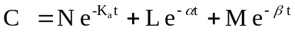 | (9.116)
where Ka, α and β have usual meanings. L, M and N are coefficients.
The 3 exponents can be resolved by stepwise application of method of residuals assuming Ka > α > β as shown in Fig. 9.14. The various pharmacokinetic parameters can then be estimated.
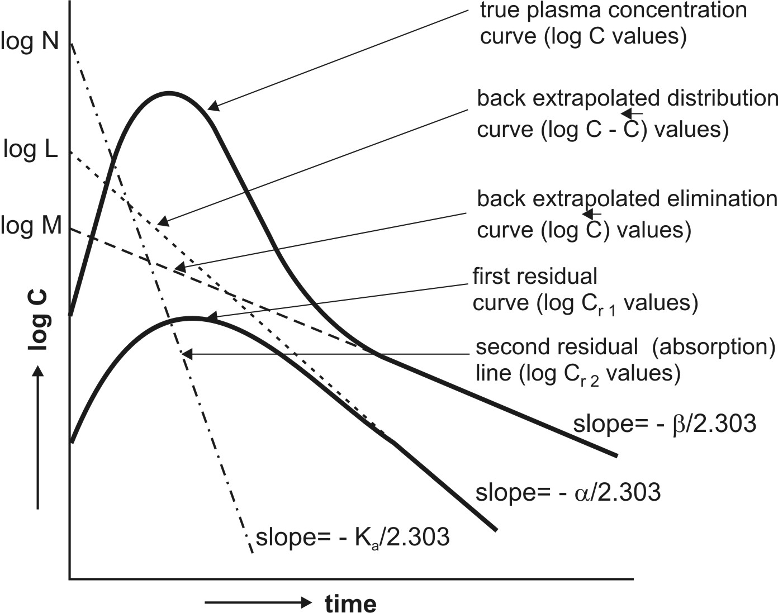
Fig. 9.14. Semilog plot of C versus t of a drug with two-compartment characteristics when administered extravascularly. The various exponents have been resolved by the method of residuals.
Besides the method of residuals, Ka can also be estimated by Loo-Riegelman method for a drug that follows two-compartment characteristics. This method is in contrast to the Wagner-Nelson method for determination of Ka of a drug with one-compartment characteristics. The Loo-Riegelman method requires plasma drug concentration-time data both after oral and i.v. administration of the drug to the same subject at different times in order to obtain all the necessary kinetic constants. Despite its complexity, the method can be applied to drugs that distribute in any number of compartments.
QUESTIONS
1. In one-compartment open model, what do you infer from plasma being called as reference compartment?
2. In compartment modelling, what does the term open mean?
3. Disposition of a drug that follows one-compartment kinetics is a monoexponential process. Explain.
4. Why do first-order rate equations require logarithmic transformations?
5. With examples, explain what you understand by primary and secondary parameters.
6. The expression Vd = Xo/Co can only be used to estimate the apparent volume of distribution of a drug that follows one-compartment kinetics when administered as i.v. bolus. Why?
7. Clearance is a more important parameter than half-life or elimination rate constant in expressing elimination characteristics of a drug. Explain.
8. Define clearance, total body clearance and organ clearance. What are the advantages of expressing clearance at an individual organ level?
9. Define and explain extraction ratio. How is it related to oral availability of a drug? What is the influence of blood flow rate and protein binding on total clearance of drugs with high and those with low ER values?
10. What are the rate-limiting steps in the hepatic clearance of drugs? Based on ERH values, to which drugs do they apply?
11. What are the advantages of administering a drug by constant rate i.v. infusion?
12. Compute mathematically the number of half-lives required to attain 90% of steady-state concentration after i.v. infusion (Hint : use equation 9.41).
13. Prove mathematically that when an i.v. loading dose is followed immediately by a constant rate infusion, the plasma concentration remains steady as long as the infusion is continued.
14. On what parameters does the time to reach steady-state depend?
15. How can the steady-state be attained rapidly? When is it advisable? Give expressions for calculating such doses for a drug that fits one-compartment model.
16. Compare the absorption characteristics of drugs absorbed by zero-order with those absorbed by a first-order process after e.v. administration.
17. Show that after e.v. administration, the Cmax that can be attained is no more than 37% of maximum level attainable with the same dose given as i.v. bolus. Why is this so?
18. What are the applications and limitations of method of residuals?
19. What is flip-flop phenomenon and when is it observed?
20. Under what circumstances is the value of Ka computed from method of residuals incorrect?
21. What are the merits and demerits of Wagner-Nelson method in computing Ka?
22. What is the influence of Ka and KE on Cmax, tmax and AUC?
23. What criteria are necessary for obtaining a valid urinary excretion data? What are the advantages and disadvantages of such a method in assessment of pharmacokinetic parameters?
24. What are the two methods for calculating KE from urinary excretion data? Compare their merits and demerits.
25. Why are urine samples required to be collected for at least 7 biological half-lives when using sigma-minus method whereas only two consecutive urine samples are sufficient in case of rate of excretion method?
26. Determination of Ka using urinary excretion data is not suitable for rapidly absorbed drugs. Why?
27. How are body tissues classified in a two-compartment model? Depending upon the drug’s lipophilicity, in which compartment brain should be included?
28. What is the cause of initial rapid decline and of subsequent slower decline in plasma levels after administration of a drug that follows two-compartment kinetics?
29. The parameter KE has different meanings for one- and two-compartment models. Explain.
30. If the plasma concentration of viomycin after i.v. bolus administration was found to be 10.0 and 5.5 mcg/ml at 2 and 4 hours respectively, assuming one-compartment kinetics, calculate:
a. the half-life of the drug
Answer : 2.3 hours.
b. the concentration of drug in plasma at time zero
Answer : 18.2 mcg/ml.
c. the Vd if dose administered was 300 mg
Answer : 16.5 liters.
d. the total systemic clearance
Answer : 82.2 ml/min.
e. the renal clearance if fraction excreted unchanged in urine is 0.8
Answer : 65.8 ml/min.
31. A 70 Kg patient is to be given oubain by i.v. infusion. The drug has a half-life of 22 hours, apparent Vd 15.7 liters and the desired steady-state plasma concentration is 0.0002 mcg/ml. Assuming one-compartment kinetics, calculate:
a. the time required to reach 90% of Css
Answer : 73 hours.
b. the infusion rate to achieve the desired Css
Answer : 0.1 mcg/hour.
c. the loading dose to attain Css rapidly
Answer : 3.14 mcg.
d. the concentration of drug in plasma after 48 hours from the start of infusion
Answer : 0.00014 mcg/ml and when loading dose is given, 0.00018 mcg/ml.
32. The equation that best fits the pharmacokinetics of paracetamol after oral administration of 500 mg dose is:
C = 1.18 (e–0.24t – e–1.6t)
Assuming one-compartment kinetics, determine—
a. peak time
Answer : 1.4 hours.
b. peak plasma concentration
Answer : 0.717 mcg/ml.
c. elimination half-life of the drug
Answer : 2.88 hours.
d. apparent Vd if fraction bioavailable is 0.4
Answer : 200 liters.
e. concentration of drug in plasma after 3 hours of administration
Answer : 0.565 mcg/ml.
33. The equation that best fits the plasma level time curve of azlocillin after an i.v. bolus dose of 2000 mg (assuming one-compartment kinetics) is:
C = 143 e–0.87t
a. What is the apparent Vd?
Answer : 14 liters.
b. What is the elimination t½ of the drug?
Answer : 0.8 Hours.
c. What will be the plasma drug concentration after 6 hours?
Answer : 0.77 mcg/ml.
d. How much of the drug will be left in the body after 6 hours?
Answer : 10.8 mg.
e. When should the next dose be administered if the drug becomes ineffective when the plasma level falls below 50 mcg/ml?
Answer : after 1.2 hours.
f. What will be the therapeutic index of the drug if the therapeutic range is 50 to 500 mcg/ml?
Answer : TI = 10.
g. How much dose should be administered to attain an instantaneous plasma concentration of 500 mcg/ml?
Answer : 7000 mg.
h. For how long will the plasma level lie in the therapeutic window if the above dose is given as i.v. bolus?
Answer : 2.6 hours.
34. The amount of drug excreted in urine after an i.v. dose of 400 mg of norfloxacin was as follows:
t (hours) Xu (mg) dXu/dt (mg/H) t*
0 0
2 49.05
4 80.0
After completing the table and using rate of excretion method, determine—
a. the elimination rate constant and half-life of the drug.
Answer : KE = 0.2303/hour and t½ = 3 hours.
b. urinary excretion rate constant
Answer : Ke = 0.077/hour.
c. fraction of drug excreted unchanged in urine
Answer : 33.4%
d. whether the drug can be used for urinary tract infections?
35. The half-life of propranolol in a 60 Kg patient is 4 hours and Vd is 5.5 liter/Kg.
a. Determine the total systemic clearance of the drug
Answer : ClT = 953 ml/min.
b. What will be its renal clearance if fraction excreted unchanged in urine is 0.047?
Answer : ClR = 44.8 ml/min.
c. Comment on the mechanism of renal excretion of drug.
d. If the drug is eliminated only by hepatic and renal routes, what will be the hepatic extraction ratio if blood flow to the liver is 1.5 liter/min?
Answer : ERH = 0.6054.
e. If the blood flow rate to the liver reduces to 0.8 liter/min in situations of CCF, what will be the new hepatic and total systemic clearance values?
Answer : ClH = 484.4 ml/min and ClT = 529.2 ml/min.
f. What is the % decrease in the overall clearance of the drug?
Answer : 44.5%.
36. Following a 650 mg i.v. bolus dose of a drug to a 65 Kg subject, the plasma drug concentration was found to decline biexponentially. The equation that best described the drug kinetics was:
C = 67 e–14t + 33 e–3t
where t is in hours and C is in mcg/ml. Calculate the following:
a. The volume of the central compartment.
Answer : Vc = 6.5 liters.
b. The volume of the peripheral compartment.
Answer : Vp = 3.95 liters.
c. The apparent Vd at steady-state.
Answer : Vd,ss = 10.45 liters.
d. Volume of distribution by area.
Answer : Vd,area = 13.7 liters.
e. The microconstants K12 and K21
Answer : K12 = 4.035/hour and K21 = 6.63/hour.
f. The elimination rate constant for the disposal of drug from the central compartment.
Answer : KE = 6.33/hour.
g. The overall elimination half-life
Answer : t½ = 0.231 hours.
h. The total systemic clearance of the drug (use Vd,area for calculation).
Answer : ClT = 686.2 ml/min.
i. The plasma level of the drug after 30 minutes of i.v. dose.
Answer : 7.42 mcg/ml.
j. The infusion rate if the drug is to be given as constant rate i.v. infusion (desired Css is 20 mcg/ml).
Answer : Ro = 823 mg/hour.
k. The loading dose to attain the Css rapidly.
Answer : Xo,L = 130 mg.
- Estimation of K_{a} for a drug that follows multicompartment kinetics by Loo-Riegelman method requires plasma concentration-time profile both after oral and i.v. administration. Explain.
- How does Loo-Riegelman method for estimation of K_{a} differ from Wagner-Nelson method? Discuss their merits and demerits.

